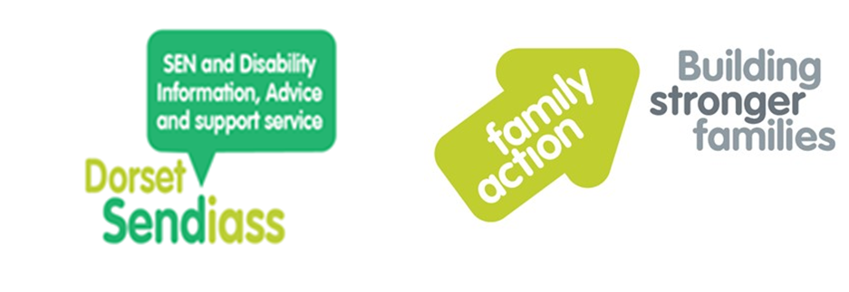
Summary of Young Person views
Supporting the needs assessment for an EHC plan

If you’d like help in completing this form contact:

- the setting or school SENCO

- the Special Educational Needs and Disability Information Advice and Support Service (SENDIASS) who offer impartial information and support

Website: www.dorsetsendiass.co.uk
Email: dorset.sendiass@family-action.org.uk
Tel: 01305 595477

- the SEND Assessment team; we’re happy to help by phone or by meeting with you.
Email: senteam@dorsetcouncil.gov.uk
Tel: 01305 224895

Young person’s name:

Date of birth:

Address of
young person:

Parent or carer name(s):

Address
(if different from above):

Telephone number(s):

Email address:

Current education/training setting:

Completed by:

Signature:

Date:

Dear Young person

A request for a needs assessment for an Education, Health and Care (EHC) plan is being made for you. Your views and the information you provide will play a key part in the assessment and the EHC Plan, if they are agreed.
Only complete as much of the form as you feel comfortable with or is relevant, but the information you provide will help us to have a better understanding of you and your needs. Use the further information section at the end of this document if you wish to tell us anything else.
You may like to keep a copy of this form and information. You can use it to share with other agencies if they ask for similar information.

We know that things can change for young people, so if you want to give us an update during the assessment process, then contact us at any time. Once the SEND team has received the Request for a Needs Assessment, they’ll give you the details of your Planning Coordinator who’ll be your point of contact.

At the end of the assessment process, the we’ll decide whether to issue an EHC Plan or not. If the decision is not to issue an EHC Plan, we’ll give you feedback on why we feel that a plan is not required at this time, as well as your legal rights of appeal.

Transport

Eligibility for transport assistance is not automatic or guaranteed. See our transport policy https://www.dorsetcouncil.gov.uk/education-and-training/schools-and-learning/policies/school-admissions-policies/transport-policies.aspx for details.

If you do receive an EHC Plan, have you thought about how you will get to and from school/setting?

Which of the following do you feel are suitable modes of transport:
- You can drive yourself Yes / No
(we can send you information about a Personal Travel Budget)
- Shared transport/mini bus Yes / No
- Public transport/school bus Yes / No

0-25 SEND Assessment Team

Who is currently involved in supporting you?

During a needs assessment for an EHC plan, we have a duty to seek information from others including:
- your current education provider or setting
- a health professional
- an educational psychologist
- a social care professional

Name | Role or Title | Contact details

What written information or reports have these people already provided you with?
For example, Speech and Language reports, paediatric clinic letters, occupational therapy programme etc. Attach copies if you have them available.
Who am I?
How do you spend your time, what do you enjoy doing? Do you belong to any clubs or enjoy any sports? Are you happy spending time on your own? What is important to you? What motivates you? What do you worry about? What makes a good or bad day for you?

What are my strengths and weaknesses?
For example, things you are good at, your strengths, aspects of your personality. What are you proud of.

Important people in my life:

Who lives in your home? Who is part of your family? How do you get on with family members? Who is important to you? What friends do you have in school/outside school? What about pets?

How I communicate:

How I express myself
How do you make your needs and wants known? For example, your ability to communicate using language. Are you comfortable communicating with others? Do you use gestures, signs, visual supports, PECs?

Communication through behaviour:
How do people know if you are angry, upset, anxious or happy? How do you show/tell people?

How you understand others
For example, your ability to understand spoken language. Is your understanding of language very literal? Do you struggle to understand non-verbal cues, signs, visual prompts and gestures?

How do you feel and communicate in social situations?
Do you like to join in conversations? Do you pay attention and listen to others? Are you good at dealing with a loss or bad news?

Your development and learning

At home
How do you spend your time? Do you recognise your own abilities? What do you find difficult?

Outside the home and in the community
Do you attend clubs, do you have any hobbies, and do you join in activities? What do you enjoy doing? How do you get on with others?

At school/ college/ post-16
Do you enjoy going? Do you like learning? Do you feel confident about learning? What do you find easy/difficult?

Your views about the progress you are making
For example, in reading, writing and maths. Attention and concentration. Independence and confidence. How well do you feel your current setting is supporting you?

My emotions and behaviour

Feelings and emotions
For example, how do you express your feelings and emotions? What makes you happy, sad, angry, scared, anxious etc.? How do you generally feel about yourself? How well can you manage your emotions?

Behaviour at home
For example, joining in with family life, sharing, listening to and carrying out requests, co-
operating with daily routines and tasks? What helps you to promote positivity in yourself?

Behaviour outside the home and in the community
For example, are there any feelings or behaviours you have that are difficult to manage outside the home? Are you aware of dangers outside the home? Do you need support to keep yourself safe?

Behaviour at school/ college/ post-16
For example, how are your relationships with other young people and teachers? Do you struggle to follow the rules?

How well do you manage change or transitions?
For example, do you need extra support or reassurance to go into school/college or setting? How well do you cope with changes in your timetable or routine or moving from one activity to another? Are you comfortable around unfamiliar people?

Your views as a young person

What is important to you now?
For example, what support works best for you? – a regular routine, trusted adults? Support? What would you like to achieve now or within the next year?

What are your goals and aspirations in the short term (in the next year or two)? What would you like to achieve?
For example, to be able to make friends, to concentrate for longer, to be less anxious, to be happy to go to school. To improve your grades etc.

What are your goals and aspirations in the long term? What would you like to achieve?
For example, to be able to manage your emotions, to be as independent as possible, to go to college/ further education, jobs etc.

What is important to you for the future?
For example, your goals and aspirations, what you want to do or be in the future. What would you like to achieve in the longer term?

My health

Tell us about any diagnoses or medical conditions

General health
For example, eating habits, sleep pattern. What support or encouragement do you need to be well and healthy, for example with medication or exercise?

Physical skills
For example, mobility, walking, running, coordination, drawing pictures, writing, manipulating puzzle pieces.

Care needs, daily living and Independence

How independent are you: personal care?
Do you need extra support with personal care?

What support do you require for your care needs throughout the day, for example, level of care, encouragement, reminders?

Life skills and independence?
For example, awareness of how to keep yourself safe, vulnerability to others, road safety?

What support do you need to be more independent at school/college/post-16 and in the community?

Preparation for Adulthood – (those in in NCY9 and above)
How well are you being prepared for adulthood?

Education & Employment:
For example, your ability to make choices or decisions, listen, follow instructions. Level of independence. Exploring different education or employment options.
What is working well? | What more support is needed?

Independent Living:
For example, your ability to manage day to day routines such as personal hygiene, food preparation, budgeting money.
What is working well? | What do they struggle with? What more support is needed?

Participation in Society:
For example, having friends and supportive relationships, joining and participating in groups or clubs, ablity to access public transport.
What is working well? | What isn’t going well? What more support is needed?

Healthy Living:
For example, being healthy and safe, awareness of danger, what support do you need to be healthy, take medication, exercise?
What is working well? | What is not working well? What more support is needed?

Any other information?

Is there any other information that you feel needs to be taken into account during the needs assessment or when drafting the Education, Health and Care (EHC) plan, if one is agreed?

If you would like to attend a different school or educational setting then let us know.

